**Project Work Plan**

*Team Members and Roles:*

The online shopping database development staff as shown in the following table.

|  |  |
| --- | --- |
| **Group Member** | **Team Member Role** |
| Roha Seyoum | Project Manager/DBA |
| Brandon Russell | Developer/ DBA/Team Lead |
| James Kamando | DBA/ Database Modeler |
| Joshua Oluwadamilare | DBA / Business Analyst |
| Tinuola Okusanya | Business Analyst/DBA |

The project manager is responsible for preparing and layout a project schedule (timeline). The business analyst will establish the database system requirements based on the business user and the stakeholders needs. The developer will develop SQL script. The Data Modeler will design the ER diagram. The DBA will develop and implement the designed database.

*Meeting and Communication Plan:*

Weekly Meeting Schedule – Sunday @ 3PM EST via WhatsApp. The group meeting will be setup by the project manager. Additional communication was performed using group discussion board and personal email. The Project manager posted online chat conversation in the group locker for reference.

*Team Members Contact Information:*

|  |  |  |
| --- | --- | --- |
| **Group Member Name** | **Telephone Numbers** | **Email Address** |
| Brandon Russell | 678-435-1858 | [rbrandon87@gmail.com](mailto:rbrandon87@gmail.com) |
| James Kamando | 856-470-8411 | [jkamando@yahoo.co.uk](mailto:jkamando@yahoo.co.uk) |
| Joshua Oluwadamilare | 240-615-3833 | [joluwadamilare@student.umuc.edu](mailto:joluwadamilare@student.umuc.edu) |
| Roha Seyoum | 202-644-6966 | |  |  | | --- | --- | |  | [rseyoum@student.umuc.edu](mailto:rseyoum@student.umuc.edu) | |
| Tinuola Okusanya | 410-599-2379 | [okusanya@student.umuc.edu](mailto:tokusanya@student.umuc.edu) |

*Project Timeline*

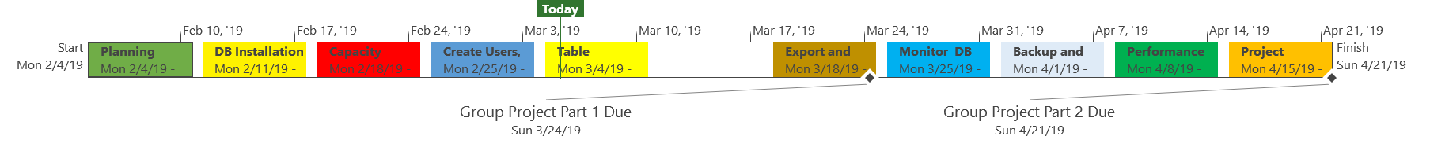

The above project time line identifies the allocated time for completion of each task.

*Project Schedule:*

Below is the project schedule that identifies the schedule of tasks and who will be responsible for completion. This Gantt chart shows the timeline for each milestone, task, the names of the project resources assigned to each task and the proposed start and end date for the entire project. For this project, each task will be worked on sequentially. The end of each milestone marks a true success in our project and ensures that every task in the project is completed on time with a great quality.

